**Assignment :**

**Module -1: Understanding of Hardware and Its**

**Components**

**Section 1: Multiple Choice**

1. Which of the following is NOT a component of the CPU?

1. ALU

2. RAM

3. CU

**4. 1 and 3 both**

**2. What is the function of RAM in a computer?**

**ANS:-** RAM (Random Access Memory) is a type of computer storage that temporarily holds data and application while a computer is running. Its main function are.

1. Temporary storage: RAM store data that the CPU uses to perform tasks.
2. Fast access: RAM allows the COU to access data quickly, which help improve computer performance
3. Volatile memory: RAM losses its data when the computer is powered off or restarted.

**3. Which of the following is a primary storage device?**

1. HDD

2. SSD

3. SD card

**4. 1 and 2 both**

**4. What is the purpose of a GPU?**

**ANS:-** Handle graphics and video rendering, Accelerate specific computations, Enhance overall system performance for graphics-intensive tasks.

**Section 2: True or False**

**5. True or False: The motherboard is the main circuit board of a computer**

where other components are attached.

**ANS:- True**

**6. True or False: A UPS (Uninterruptible Power Supply) is a hardware**

device that provides emergency power to a load when the input power

source fails.

**ANS:- True**

**7. True or False: An expansion card is a circuit board that enhances the**

functionality of a component.

ANS:- **True**

**Section 3: Short Answer**

**8. Explain the difference between HDD and SSD.**

ANS:-HDD (Hard Drive Disk) Uses physical disks and mechanical heads to read/write data, making it slower and more prone to mechanical failure.

SSD (Solid State Drive) Stores data in interconnected flash memory chips, providing faster read/write speeds, lower latency, and higher reliability.

**9. Describe the function of BIOS in a computer system.**

ANS:-The BIOS is firmware that controls and configures the hardware components of a computer system. Its main functions include.

1. hardware initialization: BIOS initializes and configures hardware components like the keyboard, mouse, hard drive, and RAM.
2. Boot process: BIOS helps the computer boot up by loading the operating system from storage devices.
3. Hardware setting: BIOS provides setting for configuring hardware components, such as boot order and time/date setting.
4. Low-level input/output operations: BIOS manage basic input/output operation between hardware components.

**10. List and briefly explain three input devices commonly used with**

computers.

ANS:-1 KEYBOARD - Allows users to type text and commands,

2 MOUSE - Enable users to interact with graphical interface and navigate on-screen elemets,

3 SCANNER - Capture images or documents and convert them into digital format,

**Section 4: Practical Application**

11. Identify and label the following components on a diagram of a

motherboard:

● CPU

● RAM slots

● SATA connectors

● PCI-E slot

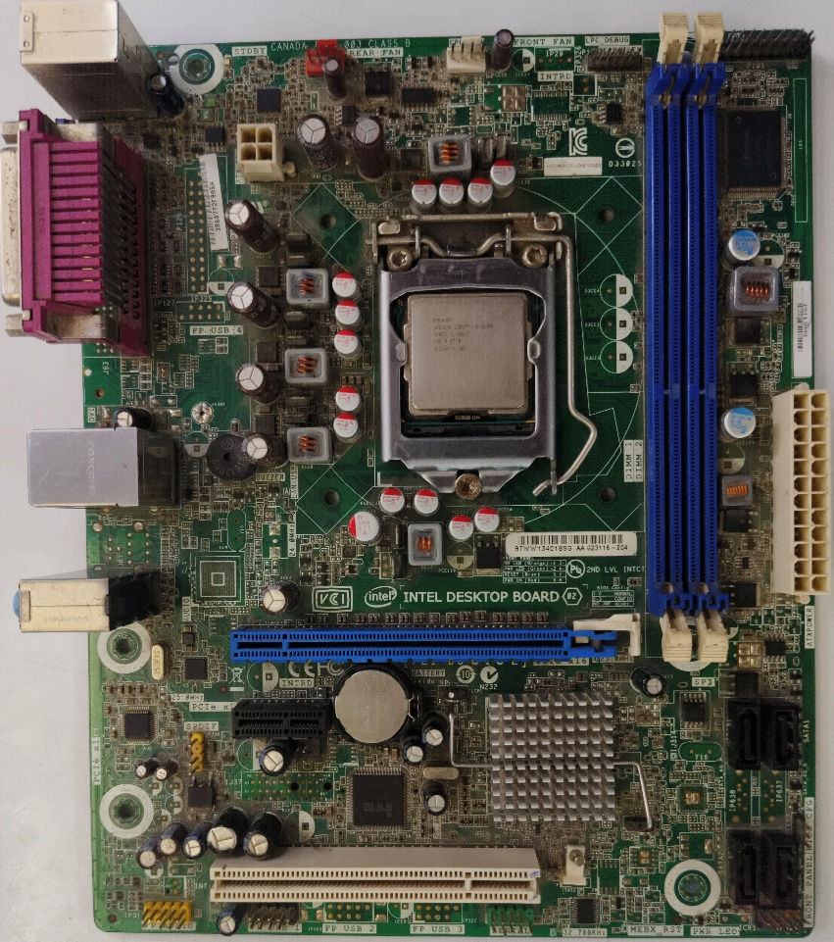

CPU

PCIe

SATA PORT

RAM SLOTS

**12. Demonstrate how to install a RAM module into a computer.**

ANS:-1. Shut Down: Power off your computer and unplug the power cord.

2. Ground Yourself: Static electricity can damage components, touch a grounded metal object or wear an anti-static strap.

3.Choose the right RAM: Ensure the ram module you want to install is compatible with your computer’s motherboard.

4. Locate RAM slots: Find the RAM slots on your motherboard, usually near the CPU.

5. Remove protective covering: take of the protective covering from RAM module's gold contacts.

6. Align the module: match the RAM module's notches with the slot’s tabs.

7. Insert the module: Gently push the RAM module in to the slot at a 45-degree angle.

8. Secure the module: firmly push the module down until it clicks into place.

9. Verify: Check that the module is securely seated and the clips are holding in the place.

10. Reassemble: Reattach any panels or covers you removed.

11. Power on: Plug in the power card and turn on your computer. The BIOS or operating system should recognize the new RAM.

(Remember to handle the RAM module by the edges to avoid touching the gold contacts.)

**Section 5: Essay**

**13. Discuss the importance of proper cooling mechanisms in a computer**

system. Include examples of cooling methods and their effectiveness.

ANS:-Cooling mechanisms are crucial in computer systems to prevent overheating, which can cause damage, slowdowns, and crashes, effective cooling ensures reliability and performance.

**Example of cooling methods:**

1. Air Cooling : Fans and heat sinks dissipate heat.

2. Liquid Cooling : Liquid circulates through tubes, absorbing heat.

3. Heat pipes : Efficient heat transfer from components to heat sinks.

These methods help maintain optimal temperatures, ensuring system stability and longevity.

**14. Explain the concept of bus width and its significance in computer architecture.**

ANS:Bus Width: Refer to the number of bits (data lines) that can be transmitted simultaneously over a bus, a communication pathway between components.

Significance: A wider bus allows more data to be transferred at once, increasing data transfer rates and improving system performance. Common bus width include 32-bit, 64-bit, and 128-bit.

**IMPACT:** Wider buses enable:

> Faster data transfer

> Improved system performance

> Imvreased bandwidth

In short, bus width directly affects data transfer speed and system performance.